# Configuration of MySQL Database in AWS

Contents

Configuration of MySQL Database in AWS 1

Step 1: Create the Database in AWS 1

Step 2: Update your Security Group to add your local IP address to Inbound Traffic 2

In this tutorial, you will create a MySQL database on version 8.16 using Amazon’s RDS. The database will contain a schema called ‘irs_990’.

## Step 1: Create the Database in AWS

* 1. Log into your [AWS console](https://aws.amazon.com/console/) and navigate to the RDS service
  2. Choose ‘Databases’ from the left-hand navigation menu item
  3. From the ‘Databases’ page, click ‘Create Database’ from the grid view
  4. From the database creation screen, update the following configuration elements:

|  |  |
| --- | --- |
| Configuration option | Setting |
| Choose a database creation method Info | Standard Create |
| Engine Type | MySQL |
| Edition | Default |
| Version | MySQL 5.7 or 8.16 (choose one that is compatible with your workbench) |
| Templates | Free Tier |
| DB instance identifier | database-3 (Note: can create a name relevant to your solution) |
| Credentials settings | Enter your username and password appropriate for the database. |
| DB Instance Class | db.t2.micro |
| Storage | default |
| Availability & durability | default |
| Connectivity | Choose ‘Create New VPC’ |
| Additional connectivity configuration | Subnet group: default  Publicly accessible: Yes  VPC Security Group: Create New (provide a name for your SG)  Database port: 3306 |
| Database authentication | Default |
| Additional configuration | Initial database name: master  DB parameter group: default  Option group: default |
| Backup | Default |
| Monitoring | Default |
| Log exports | Default |
| Delete Protection | Default |

* 1. Click ‘Create Database’
  2. Once your database is created, be sure to save your connection parameters. You will need the Endpoint, Port, and your security group.

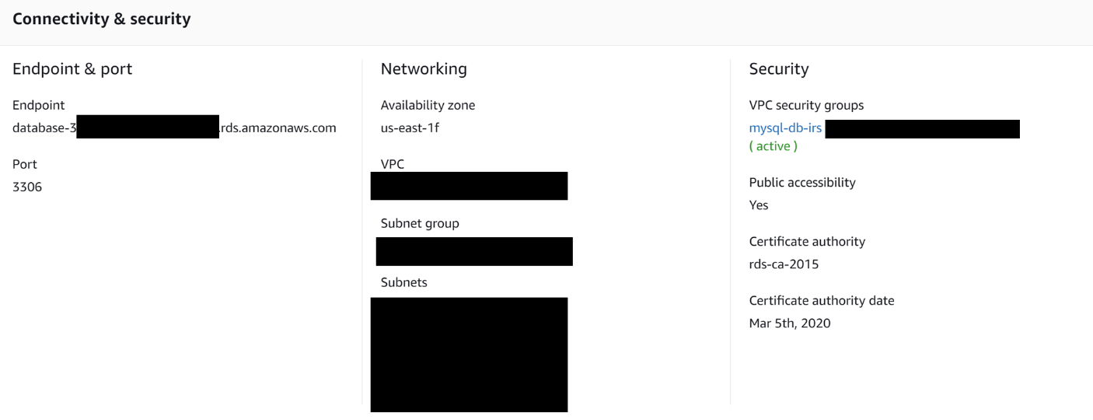

## Step 2: Update your Security Group to add your local IP address to Inbound Traffic

* 1. Navigate to your Security Group by clicking the hyperlink from the Security settings on your Databases Dashboard
  2. From the Security Group Configuration menu, select the ‘Inbound’ tab

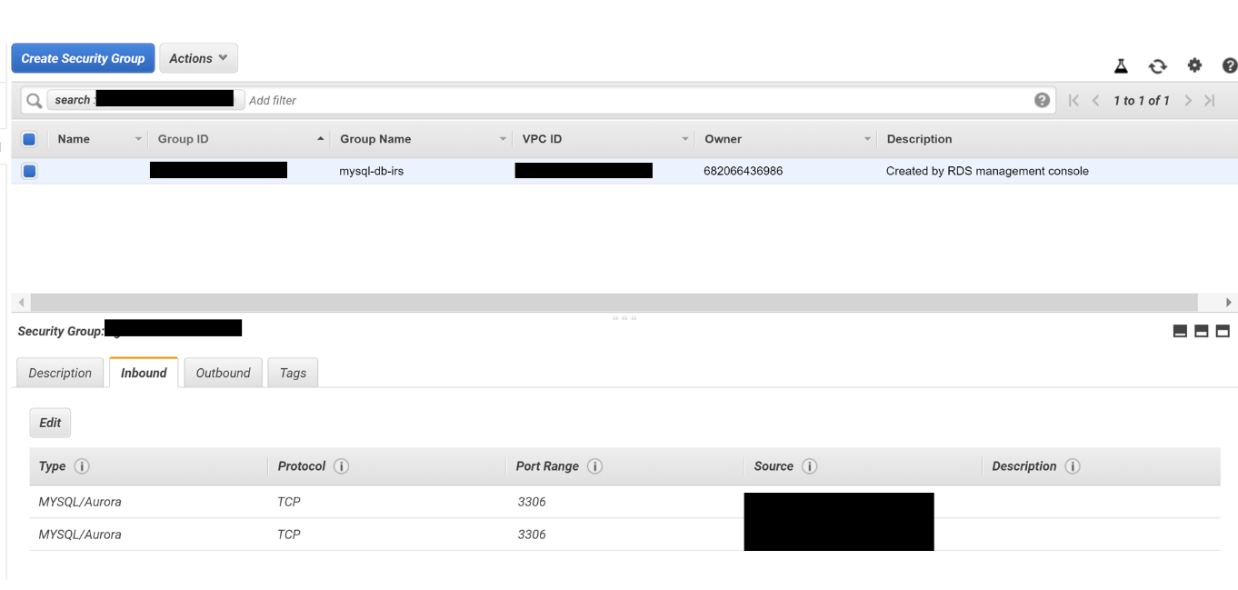

* 1. Add your IP to the ‘Inbound’ parameters by specifying ‘My IP’

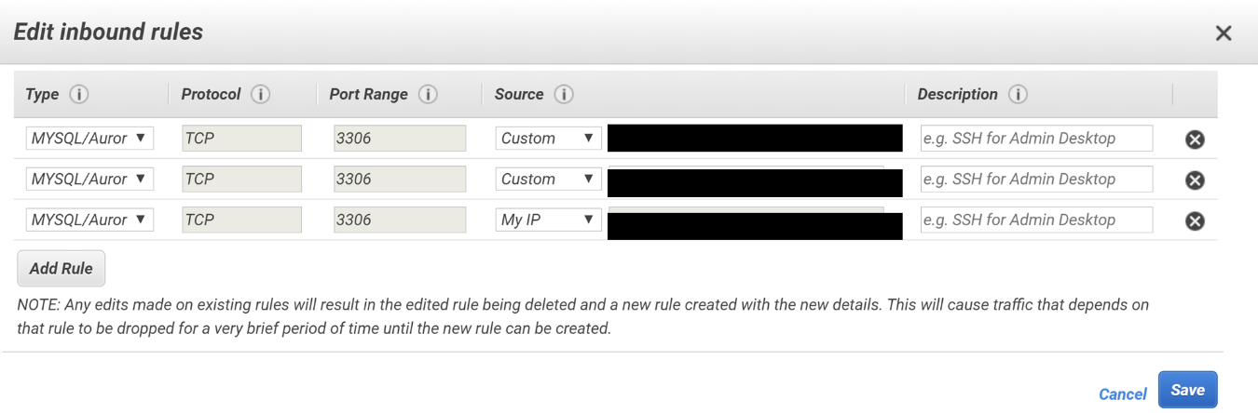

* 1. Once you have added your IP address, you should be able to test your connectivity. Open the MySQL Workbench from your computer and add the connection parameters to create the AWS Connection.

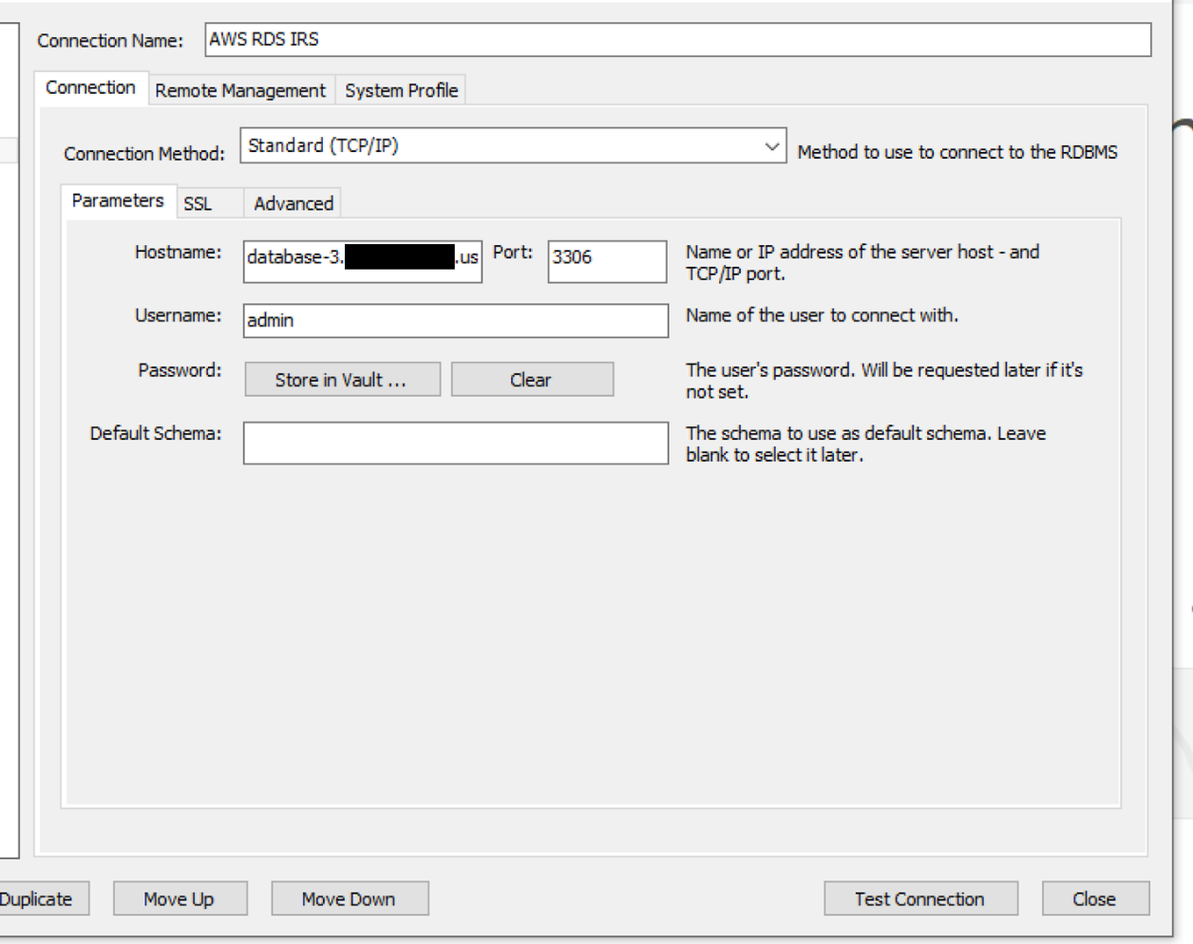

* 1. Once connected run the DDL file in Assignment 1 in the query window to construct the database.
     1. You can test your DDL file by running a simple select query on t_sup_supplier:

Select * from t_sup_supplier